State Machine Diagram
A state machine is any device that stores the status of an object at a given time and can change status or cause other actions based on the input it receives. States refer to the different combinations of information that an object can hold, not how the object behaves. In order to understand the different states of an object, you might want to visualize all of the possible states and show how an object gets to each state, and you can do so with a UML state diagram.
Each state diagram typically begins with a dark circle that indicates the initial state and ends with a bordered circle that denotes the final state. However, despite having clear start and end points, state diagrams are not necessarily the best tool for capturing an overall progression of events.

State diagram symbols and components
You can include many different shapes in a state diagram, particularly if you choose to combine it with another diagram. This list summarizes the most common shapes you may encounter.

Composite state
A state that has substates nested into it. See the university state diagram example below. “Enrollment” is the composite state in this example because it encompasses various substates in the enrollment process.

Choice pseudostate
A diamond symbol that indicates a dynamic condition with branched potential results.


Event
An instance that triggers a transition, labeled above the applicable transition arrow. In this case, “classes end” is the event that triggers the end of the “Being taught” state and the beginning of the “Final exams” state.
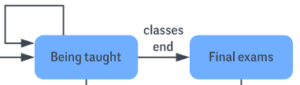

Exit point
The point at which an object escapes the composite state or state machine, denoted by a circle with an X through it. The exit point is typically used if the process is not completed but has to be escaped for some error or other issue.


First state
A marker for the first state in the process, shown by a dark circle with a transition arrow.


Guard
A Boolean condition that allows or stops a transition, written above the transition arrow.

State
A rectangle with rounded corners that indicates the current nature of an object.
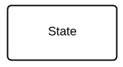

Substate
A state contained within a composite state's region. In the university state machine diagram found below, “Open for enrollment” is a substate in the larger “Enrollment” composite state.

Terminator
A circle with a dot in it that indicates that a process is terminated.


Transition
An arrow running from one state to another that indicates a changing state.
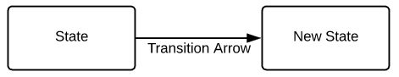

University state diagram example
This state diagram shows the process of enrollment and classes at a university. The composite state “Enrollment” is made up of various substates that will lead students through the enrollment process. Once the student has enrolled, they will proceed to “Being taught” and finally to “Final exams.”
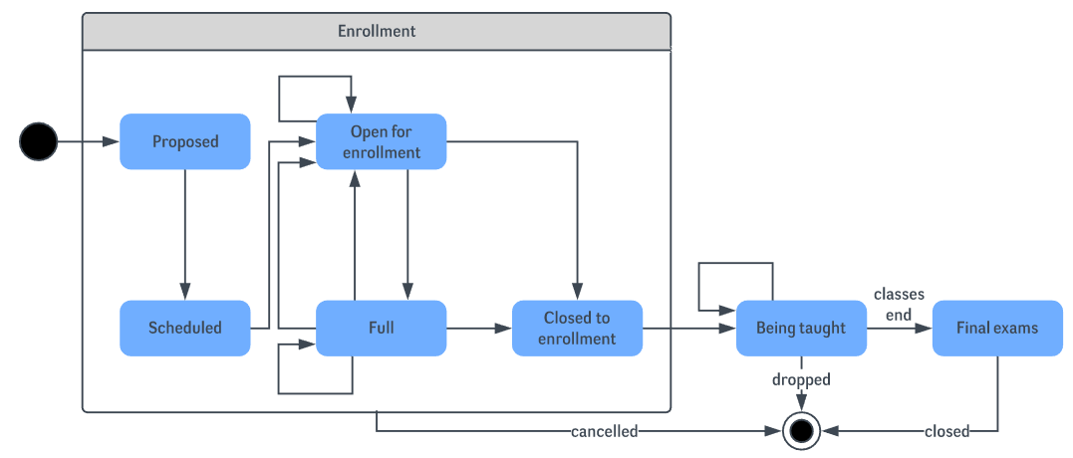

Airport check-in state diagram example
The following example simplifies the steps required to check in at an airport. For airlines, a state diagram can help to streamline processes and eliminate unnecessary steps.
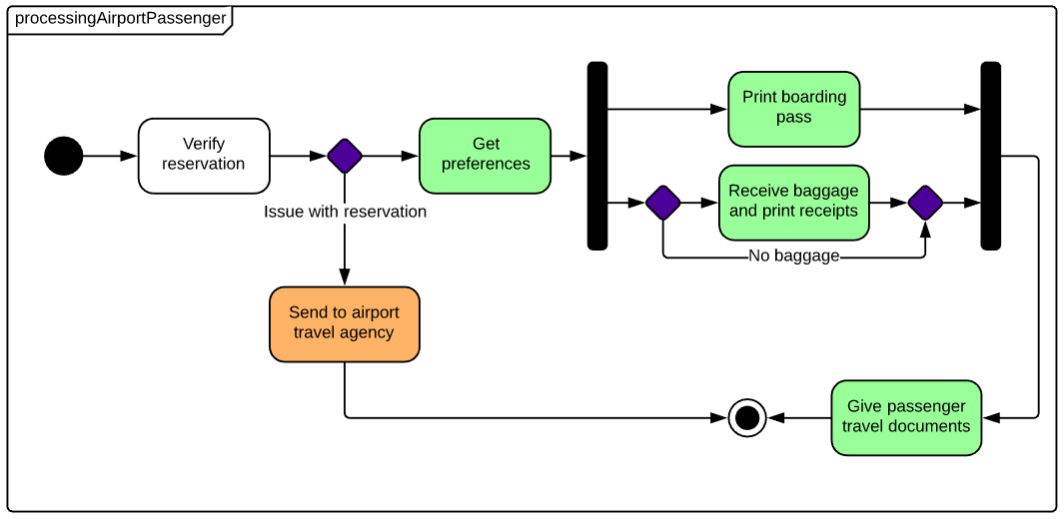

EXAMPLE QUESTION: Give a state diagram that describes the process of passing a graduate course as a set of concurrent activities. The process has as follows: To pass, a student has to attend all but two lectures, present to the class a paper she read, and complete a course project, due on the last day of the term. To give her presentation, the student is given a date by the instructor, prepares her presentation, and gives it on the assigned day. At any time, the student can drop the course. Make sure to define events, conditions, actions for transitions in your diagram, where appropriate. (10 Marks)

Deployment Diagram
In the Unified Modeling Language (UML), deployment diagrams show how elements of software and hardware are connected to one another. Since they can describe hardware, deployment diagrams are unique in the UML world.

Identify components
Deployment diagrams can serve several purposes, all of which relate to hardware. Some of these functions include:
- Capturing runtime processing for hardware elements.
- Illustrating the general topology for a given hardware system.
- Demonstrating how certain software components are deployed by specific hardware components.
Once you’ve identified the purpose of your deployment diagram, you will need to determine the elements within. The principal elements of any deployment diagram are nodes. These large 3D boxes symbolize the elements that deploy objects. The objects contained in boxes—such as stereotypes, artifacts, and components (a component is illustrated in the example below)—are the objects that are being deployed.
Lines from node to node indicate either relationships between nodes or relationships between the messages they send out. Note that deployment diagrams can achieve a high level of complexity—for example, depending on the pattern of deployment you are trying to express, you might have one node contained in another node. It may be helpful to start with a list that clearly denotes the nodes you wish to display and their interrelationships.
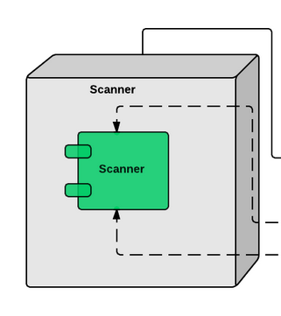

Add shapes
Turn on the UML shape libraries to begin drawing your diagram in Lucidchart. Within the UML deployment shape library, drag out your first symbol: a node. Label it and choose which shapes should be contained within the node. You could add an artifact, a component, an instance, or a basic object. The example to the right shows a component contained by the node. You can easily add, delete, or swap out elements in the node. To relabel any element with a different name, simply click and type.
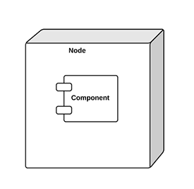
After adding your first node, add and label more nodes until you have completed the structure of your diagram. Then add the component shapes that will be deployed into the node boxes.

Connect nodes
After that, you’re ready to connect the two nodes. To add a line, drag your mouse from the red circle that appears when you hover over the shape and connect it to the appropriate shape.

Format arrows
When you draw relationships between elements inside the nodes, you will likely need to illustrate more complex connections. The Lucidchart editor allows you to change the style and arrows on each line to show a unique type of relationship. Just use the properties bar above the canvas.
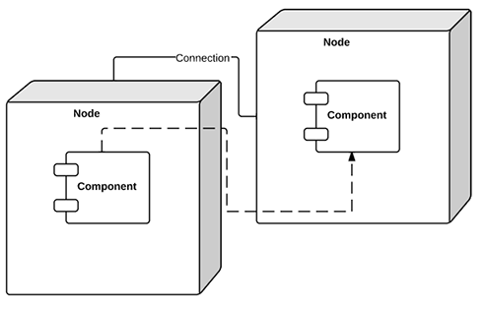

Complete your diagram
Add lines and nodes until you have finished describing the system. Feel free to add different colors to your diagram to make the content more accessible.
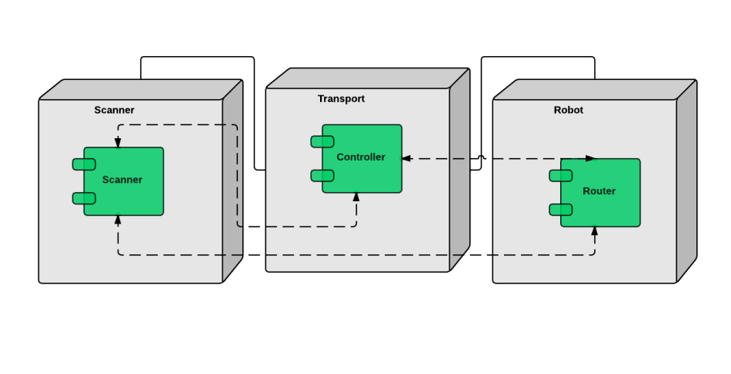
Deployment diagram elements
Association: A line that indicates a message or other type of communication between nodes. Component: A rectangle with two tabs that indicates a software element. Dependency: A dashed line that ends in an arrow, which indicates that one node or component is dependent on another.
Example 1:
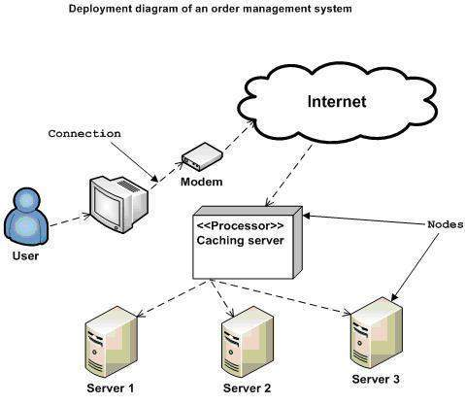

Example 2:
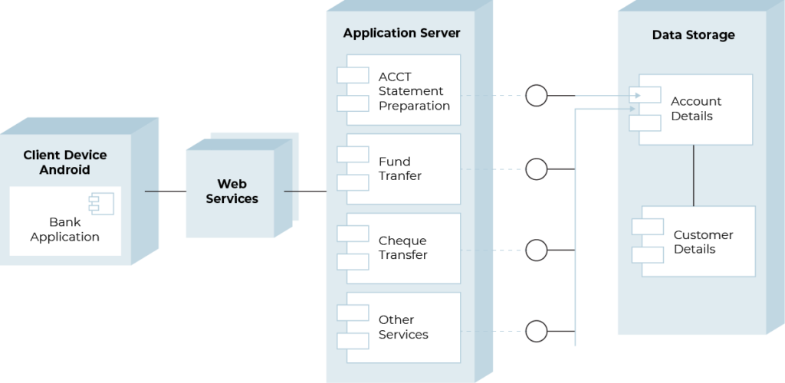
Example 3:
